**DATA ANALYTICS**

**TABLEAU**

Tableau:

**Tableau** is a powerful and fastest growing data visualization tool used in the Business Intelligence Industry. It helps in simplifying raw data in a very easily understandable format. Tableau helps create the data that can be understood by professionals at any level in an organization. It also allows non-technical users to create customized dashboards.

The tableau is a visualization is the pictorial representation of the data. A picture speaks more than words and make easy for analysis. Tableau is Reporting tool which is used create your Dashboards, Stories, Visual to get good insights into the data which is very for taking important Business Decisions.

Data analysis is very fast with Tableau tool and the visualizations created are in the form of dashboards and worksheets.

The great thing about Tableau software is that it doesn’t require any technical or any kind of programming skills to operate. The tool has garnered interest among the people from all sectors such as business, researchers, different industries, etc.

There are some main concepts one is Population and other is Sample

Population: A population is collection of all items of interest to our study and is usually denoted with uppercase N. The numbers we have obtained when using a population are called parameters.

Sample: A sample is a subset of the population and is usually denoted with lowercase n and the numbers we have obtained while working with samples are called statistics.

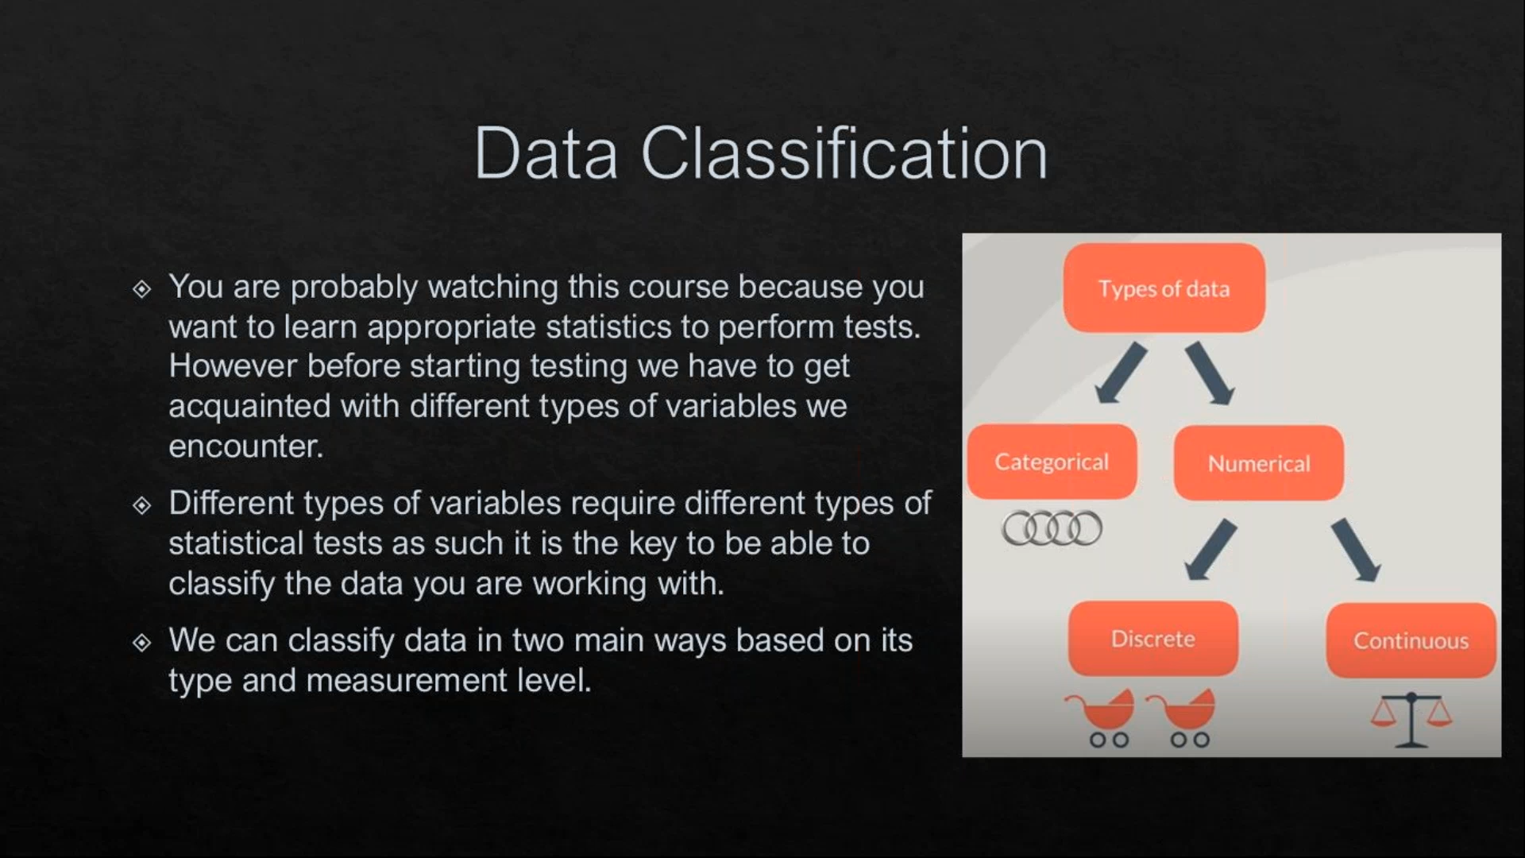

Categorical Data: Categorical data is a collection of information that is divided into groups. I.e, if an organization or agency is trying to get a biodata of its employees, the resulting data is referred to as categorical. This data is called categorical because it may be grouped according to the variables present in the biodata such as sex, state of residence, etc.

Numerical Data: Numerical data represent values that can be measured and put into a logical order. Examples of numerical data are height, weight, age, number of movies watched, IQ, etc. To graph numerical data, one uses dot plots, stem and leaf graphs, histograms, box plots, ogive graphs, and scatter plots.

Discrete values: A discrete distribution is one in which the data can only take on certain values, for example integers. A continuous distribution is one in which data can take on any value within a specified range (which may be infinite).

Continuous values: A discrete distribution is one in which the data can only take on certain values, for example integers. A continuous distribution is one in which data can take on any value within a specified range (which may be infinite).

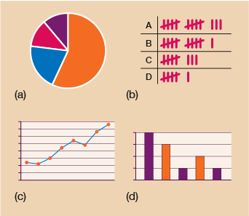

Tableau Interfaces:

TABLEAU PUBLIC

TABLEAU DESKTOP

TABLEAU SERVER

**TABLEAU**

TABLEAU ONLINE

TABLEAU READER

* Tableau Public: It is Tableau version specially build for the cost-effective users. By the word “Public,” it means that the workbooks created cannot be saved locally; in turn, it should be saved to the Tableau’s public cloud which can be viewed and accessed by anyone.
* Tableau Desktop: Tableau Desktop has a rich feature set and allows you to code and customize reports. Right from creating the charts, reports, to blending them all together to form a dashboard, all the necessary work is created in Tableau Desktop.
* Tableau Server: The software is specifically used to share the workbooks, visualizations that are created in the Tableau Desktop application across the organization. To share dashboards in the Tableau Server, you must first publish your work in the Tableau Desktop. Once the work has been uploaded to the server, it will be accessible only to the licensed users.
* Tableau Online: As the name suggests, it is an online sharing tool of Tableau. Its functionalities are similar to Tableau Server, but the data is stored on servers hosted in the cloud which are maintained by the Tableau group.
* Tableau Reader: Tableau Reader is a free tool which allows you to view the workbooks and visualizations created using Tableau Desktop or Tableau Public. The data can be filtered but editing and modifications are restricted. The security level is zero in Tableau Reader as anyone who gets the workbook can view it using Tableau Reader.

Tableau connects and extracts the data stored in various places. It can pull data from any platform imaginable. The spreadsheet application used for manipulating the data while Tableau is a perfect visualization tool used for analysis.

Tableau Working Sheet:

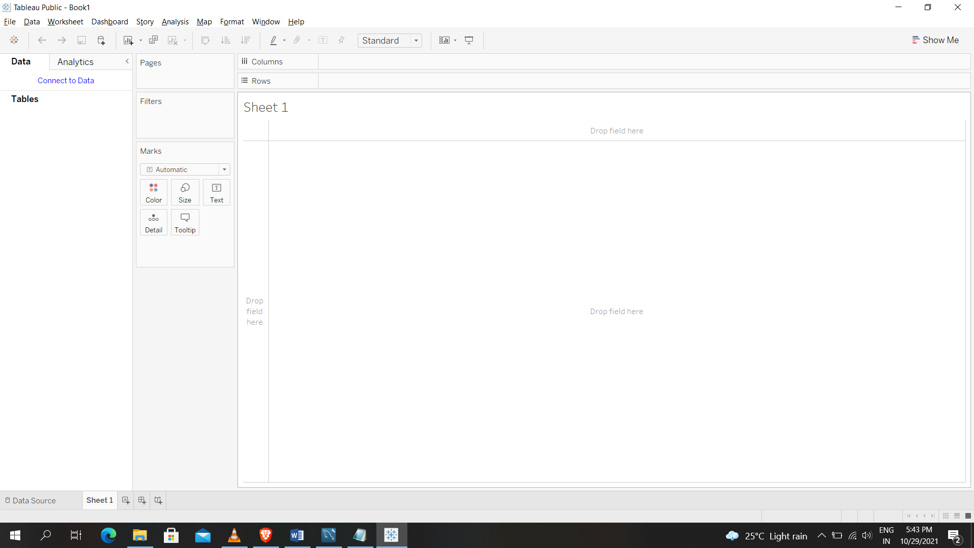

There are many keys and functions in working sheet like pages, filters, marks, columns, rows, show me, tool bar, menu bar, and index bar

Data source

It is datasource window here we can add file(excel) for our visualization and also we can connect the data by online server too.

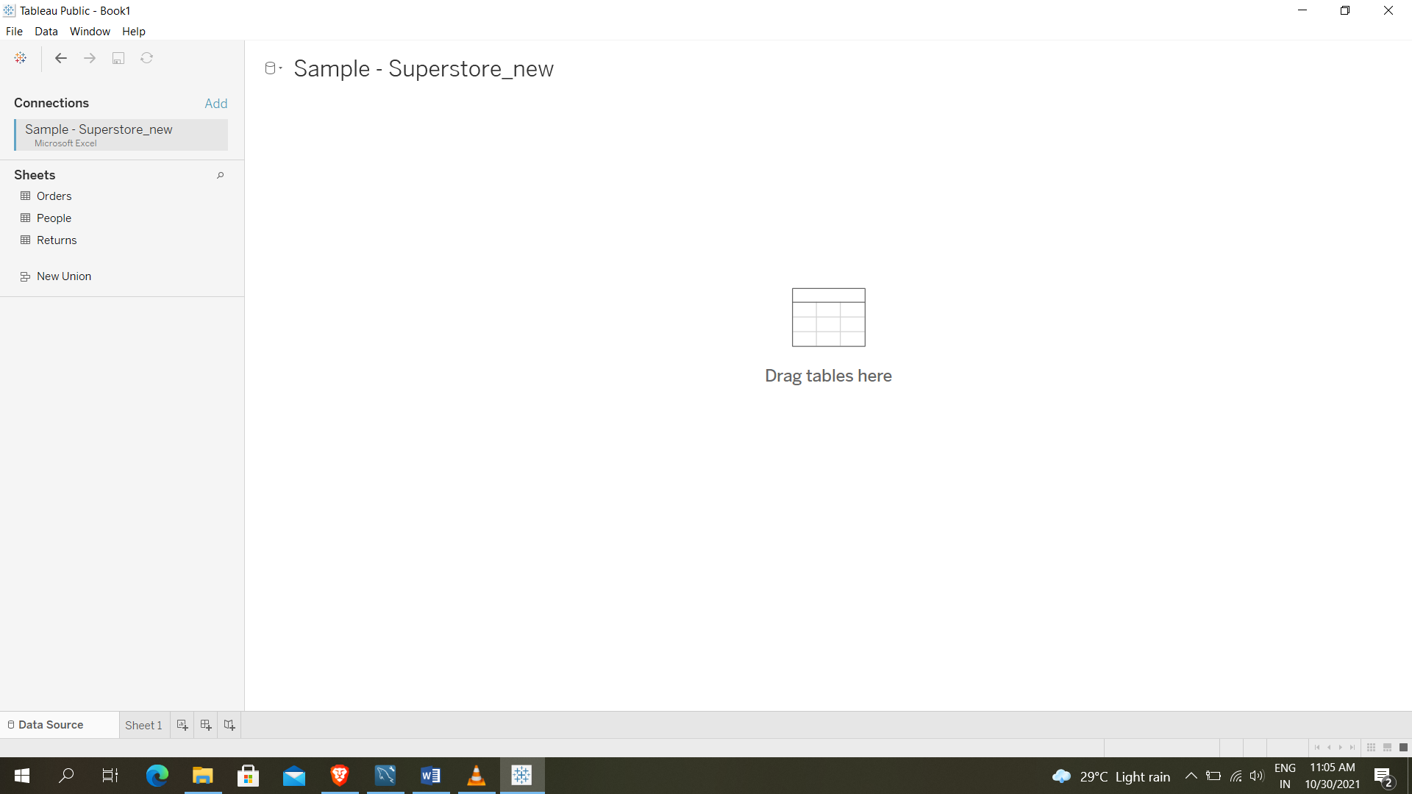

Data source window

In this window we added the Sample – Superstore new excel file in that we found Orders, People, Returns. We can drag that file to view the file content and then we supposed to go to working sheet.

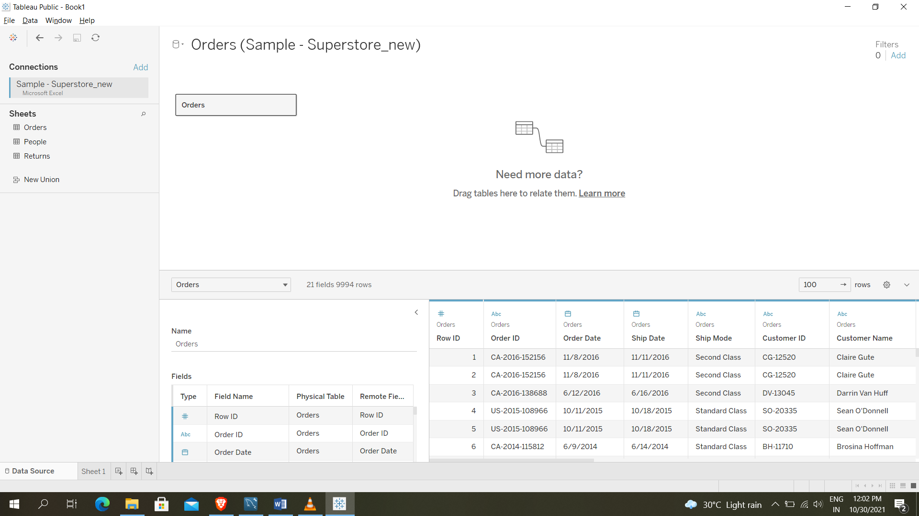

In the working sheet left side there are two columns Data and Analytics. In Data we will some tables, which are the columns of file that we dragged in data source window.

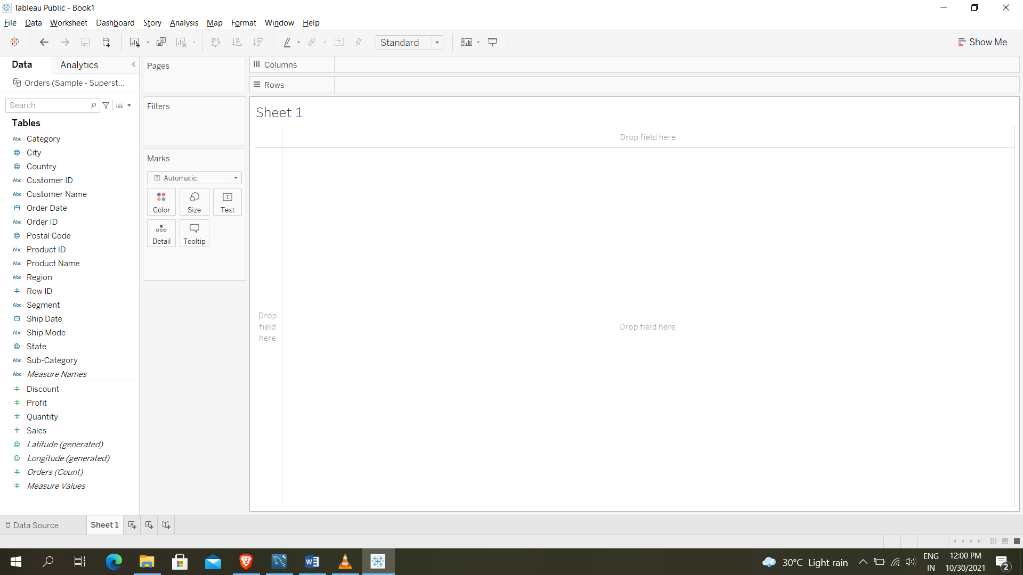

For plotting any kind of graph, bars, visualization for our content we can drag them and keep it in rows and columns, like there two set of groups or two kinds of separations in table like numerical values one set of group and quantitative values are another set of group. We can see in picture up to Sub-Category, Measure Names…., quantitative values and discounts, sales, profits…., are numerical values and there are some default columns by tableau according to the content in the file which should be visualized in work sheet According to that we should drag them in rows and columns.

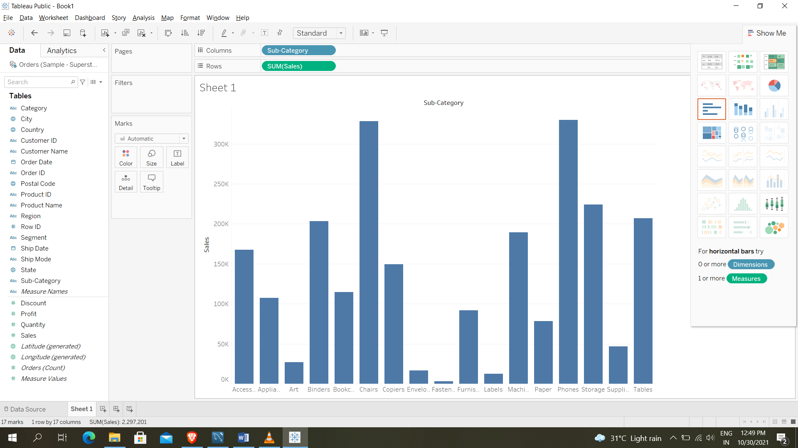

It is simple way for visualization in Bar graph. We can plot any kind of line graph, bars, circle diagrams, area wise diagrams…., like we see in Show Me. If we observe in the picture we can see in rows, there is Sum (Sales) in tableau by default it takes calculation part for visualization that to according to the data.

Line Chart

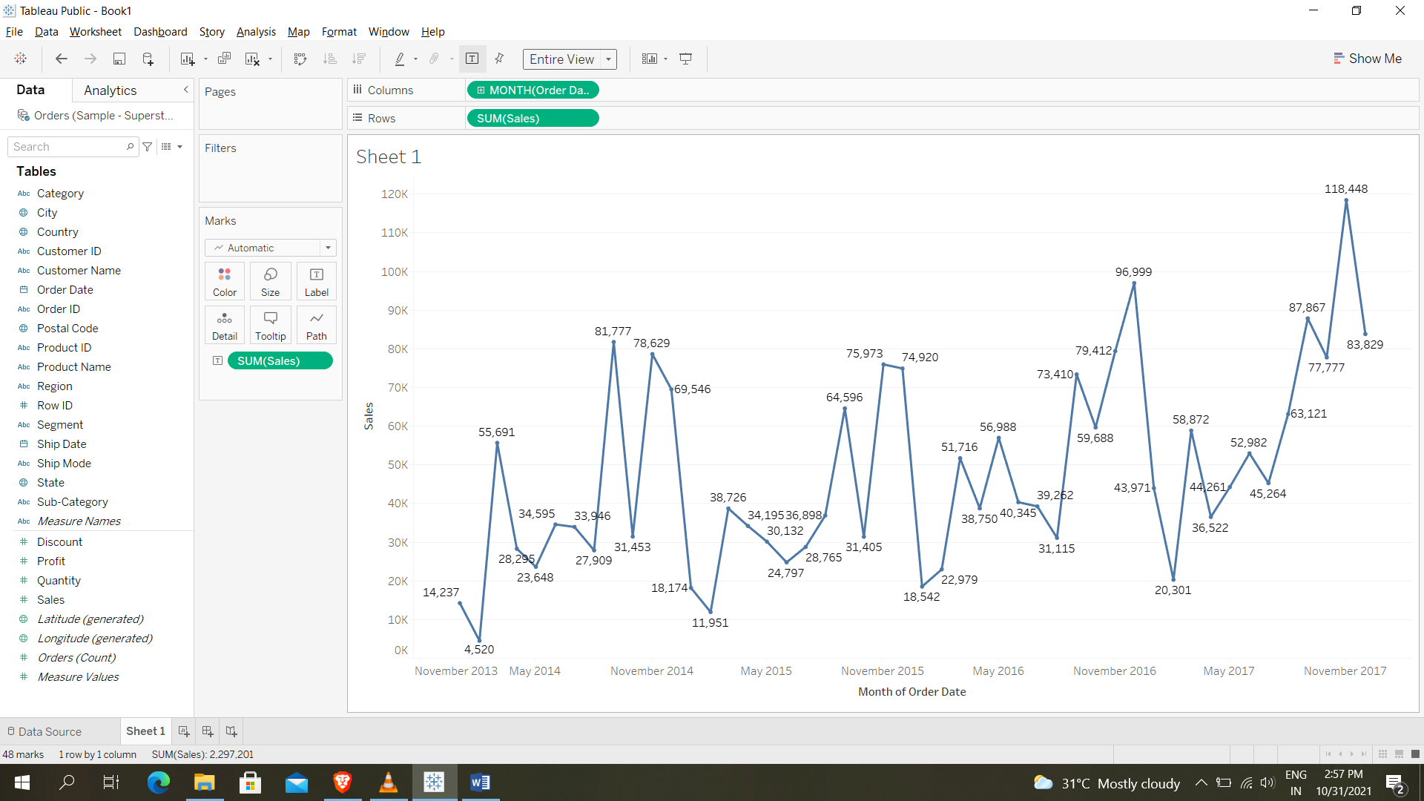

Line chart is used when there is a date data type in the visualization. It depicts how the value changes over time and we use the date field in X axis and numerical field in Y axis. Line charts are also used in forecasting to predict future values.

If we see in the picture in columns month (order date) we can change it for year and day wise order date details and also we can change sum (sales) to average and median (sales) by using measure. We can present sales like labels in graph we use label key in marks (or) by using label key in marks we can point out the sales in graph by labelling it. And we can add colors for more effective presentation in sheet of our data.

Filters

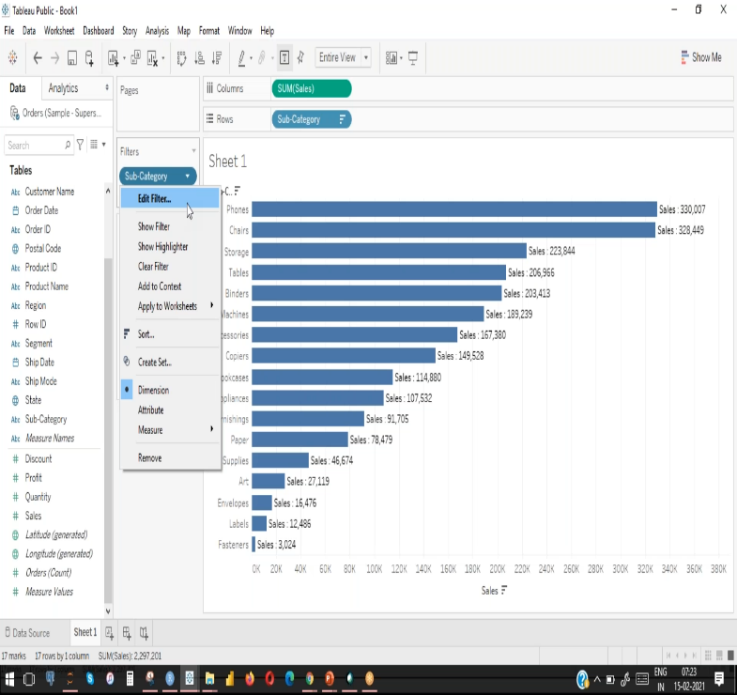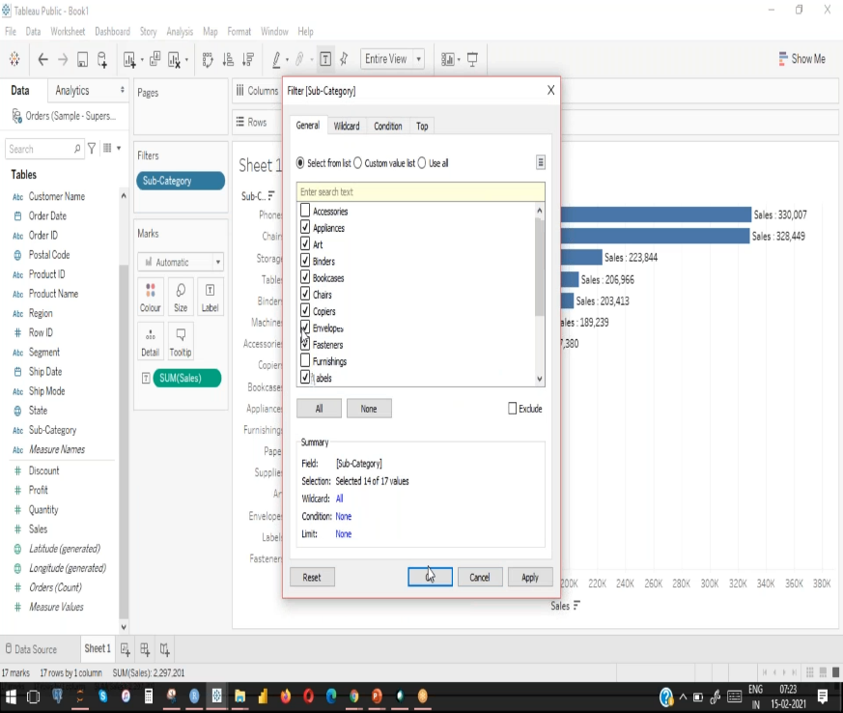

The picture is general filter or dimension filter, for example plot a graph with some selected categories then drag variable inti filter shelve then a small window will open in that you can do changes like selecting some categories.

There are options like wildcard, condition and top for alphabetical, conditional, ascending or descending order plotting graph.

Measuring filter it is used to filter the measuring values of considering some range of values, at least values, at most values…. and also we have visual filter in this filter we can filter directly on the visualized graph by selecting it directly.

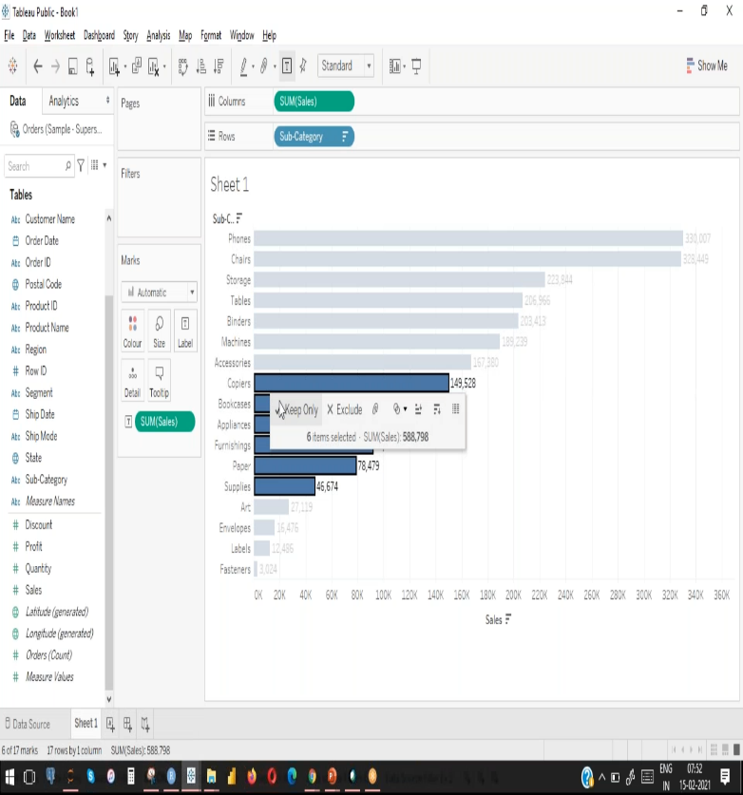 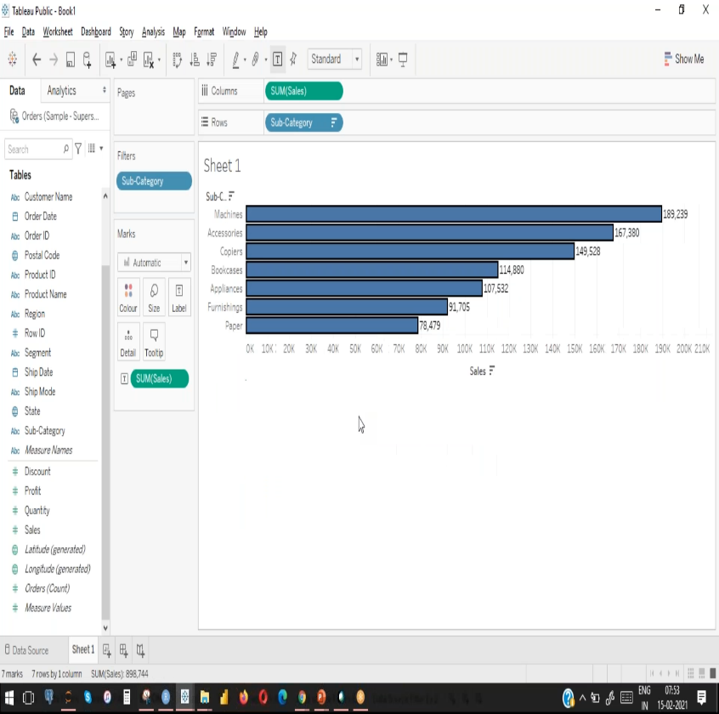

There is another filter called interactive filter which we can directly filter in right side popuped window by show filter.

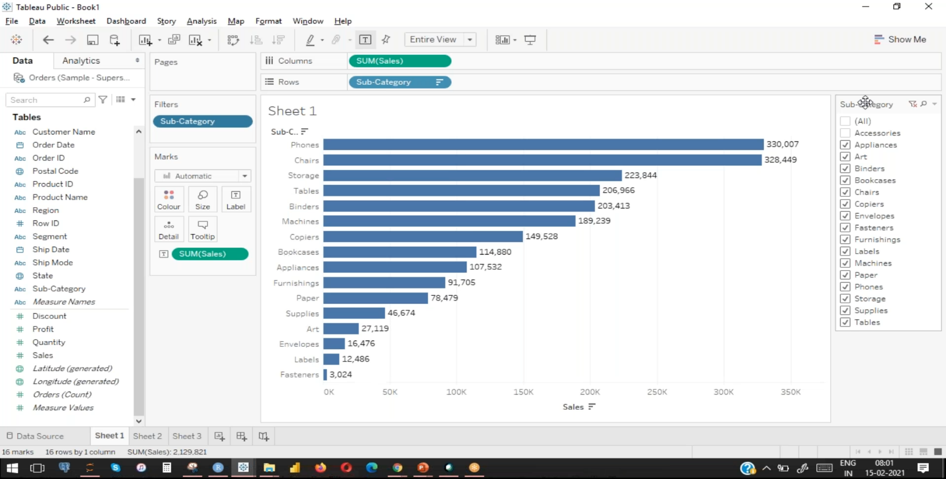

There are some concepts which apply analytics to the work sheet they are creation sets, creation groups, creation parameters

Sets

Sets are custom fields or columns created using a subset of the dat based on a condition. They can be created by manual selection ,condition or ranking and also they can be used in any aspect of the visualiation.

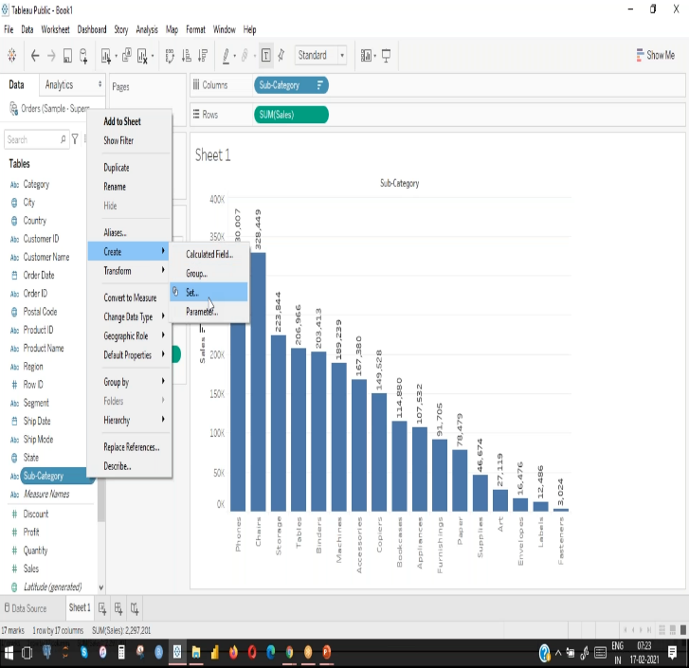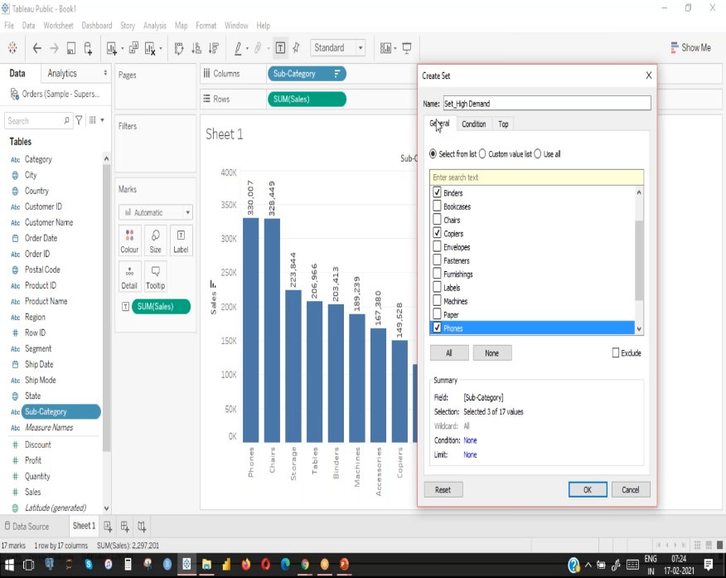

If click on any column properties there is a option create and click set then a small popup window will be open in that we create a set there are same option like in filters such as condition, top, we can add colors to selected set. We can also separate set that we created in the tableau sheet.

Groups

Groups analytic as like as set, same route for creating a group as set there we will see window in that we can create groups, we can create N numbers groups if we need we can also separate them and also add color, size too.

Parameter

Parameter is a placeholder yo replace constant and it cannot function on its own.It is connected to filter, sets, reference lines,calculations, or actions. It gives the end user the flexibility to modify data for different values. For creating parameter there is a option top in popuped windows.

Calculated Field

Calculated fields are calculations created by the user using different funtions and fields available in the data source.these custom calculations more insight from the visulazation based on the requirement. Parameters can used inside calculated fields. Calculated feilds can be univers al and an alternative for groups sets and filters

When selecting or dragging column in to work sheet (in rows, in columns) there is a option analysis in that we will see create calculated field, if we click it a popup window will open in that we can do our calculations. There are many functions in right hand side menu and that functions divided into some groups, there we can also see some description on we selected funtion for our calculations.

We can also apply if and else condition in calculated field for our requerment for plotting our graph

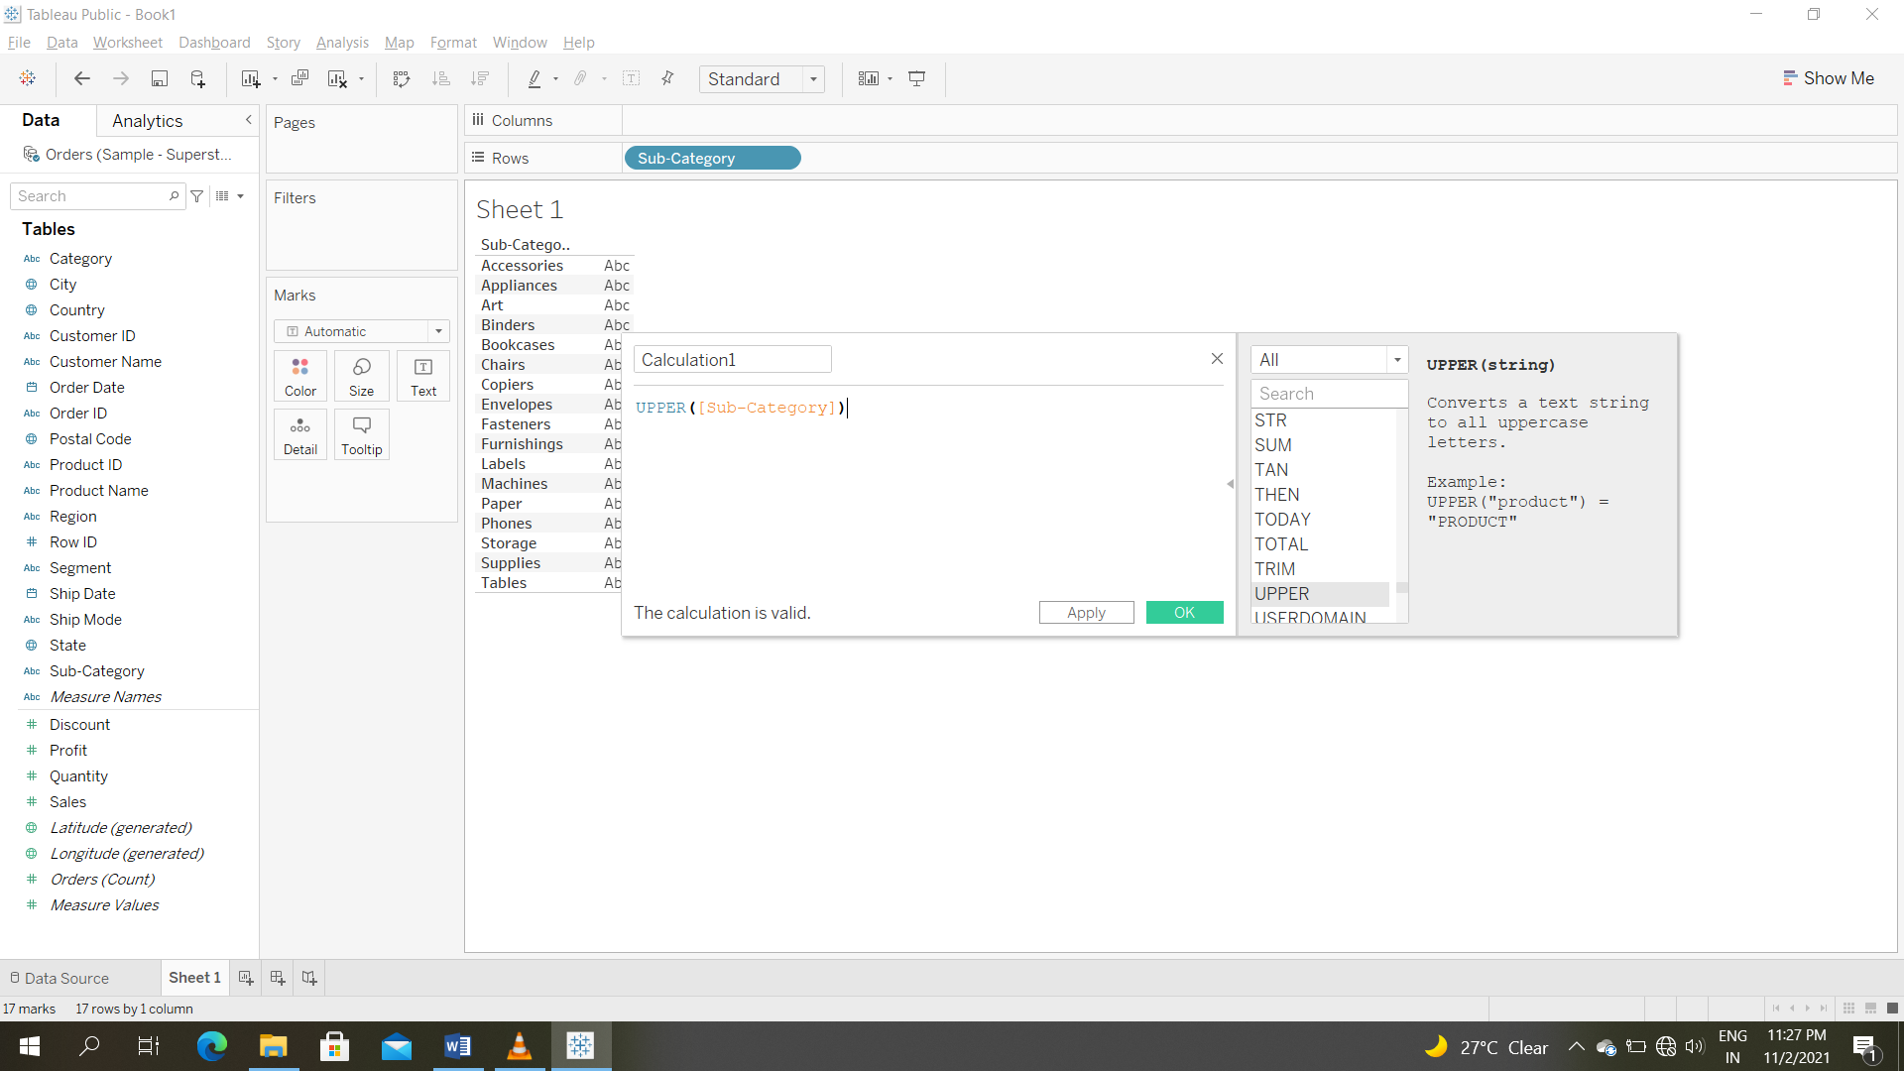

In calculated field we add date, date diff, text functions to our work sheet.